PFDM Streaming Guide (Wireless Streaming)
The new PFDM Streaming Assistant is now available!
In this update, we improved the connection flow of the Streaming Assistant, making it easier and more convenient to connect and use. We also redesigned the interface to provide a better experience.

Before you begin, please prepare the following devices and make sure the requirements are met
- PFDM 6DoF headset
- A VR-ready Windows 10 PC
- Dual-band gigabit router (for smoother gameplay, please use the 5 GHz Wi-Fi band)
For a better gaming experience, we recommend using one of the following gigabit routers:
Huawei WS7206; Xiaomi Router Pro; D-Link DIR-878; ASUS RT-AC5300;
- Category 6 or higher Ethernet cable
- Check whether your PC meets the following hardware and software requirements
Operating system: Windows 10 64-bit
CPU: Intel Core i5-4590 / AMD FX 8350 or above
GPU: NVIDIA GeForce GTX 1060 6 GB or above (laptops require at least GTX 1070 or above)
Memory: 4 GB RAM or above
Network adapter: 1000 Mbps RJ45 Ethernet port

Note: If the above requirements are not met, your experience may be affected.
Before starting, make sure the PFDM headset and controllers have sufficient battery.

Next, start the software setup process:
I. Download and install Steam, then install SteamVR
1. Steam download link: https://store.steampowered.com/about/
Click Install Steam

2. Log in to Steam
If you do not have a Steam account, please create a new account first.
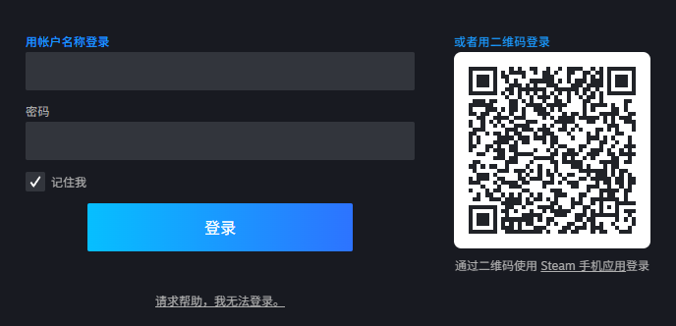
- Click Store, search for SteamVR in the search box, then click the search button
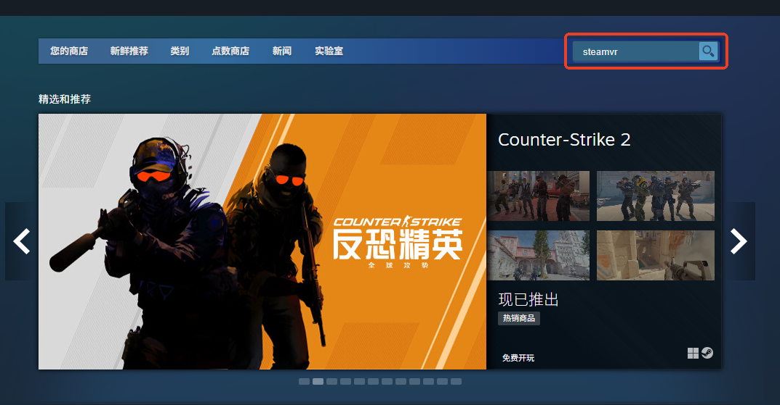

- Click SteamVR in the search results list
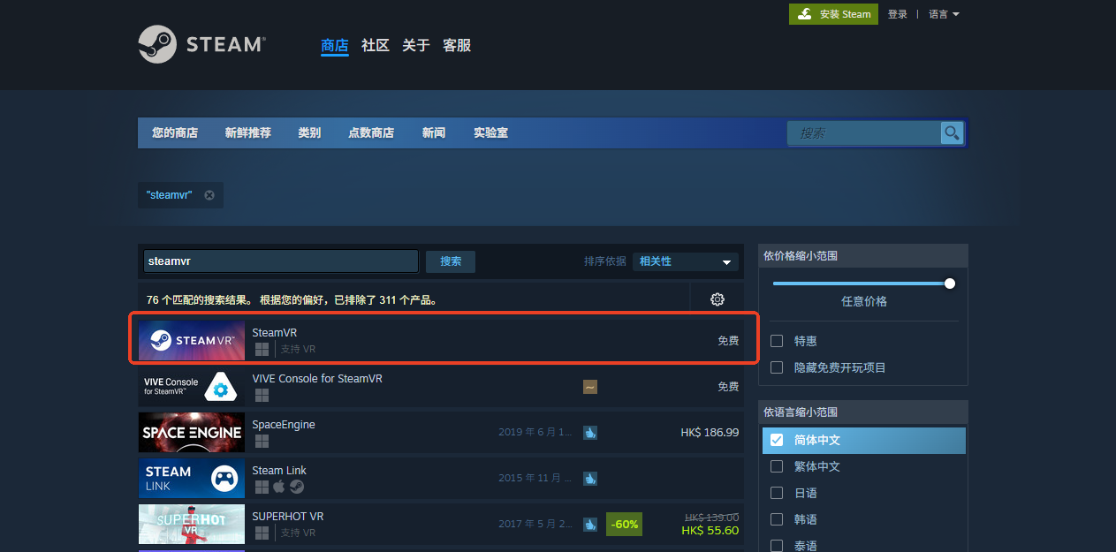

- Go to the SteamVR details page and click Play Game. SteamVR will start downloading and will be installed automatically after the download is complete.
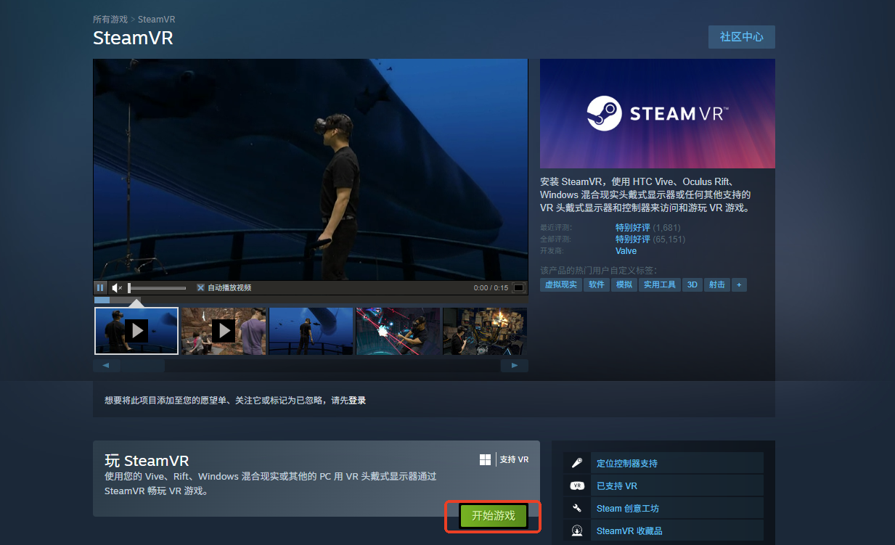

6. Search the Steam Store for the game you want to play and download it (choose a title that supports 6DoF)

II. Download PFDM Streaming Assistant
- PFDM Streaming Assistant download link:
https://pfdm.ai/pages/play-for-dream-mr-support-service-center
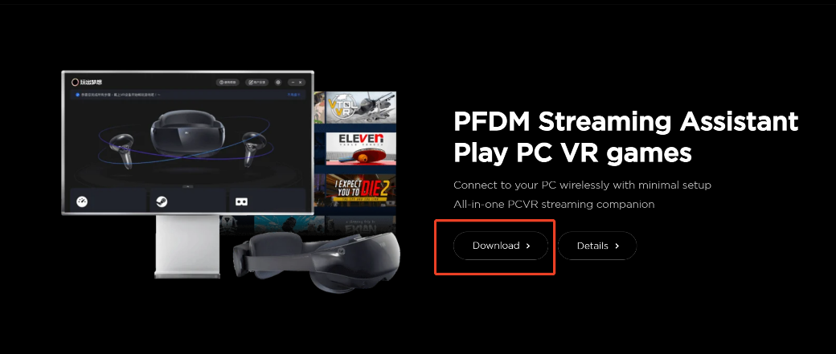

- After downloading, double-click the installer
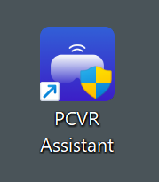
- In the setup wizard, click Next
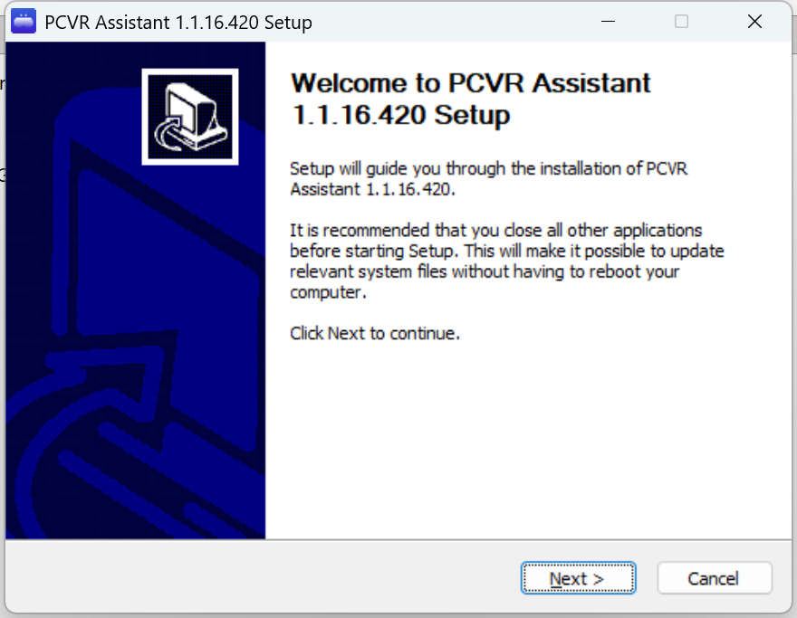
- Select the installation path. The installation path must be in English. Then click Next.
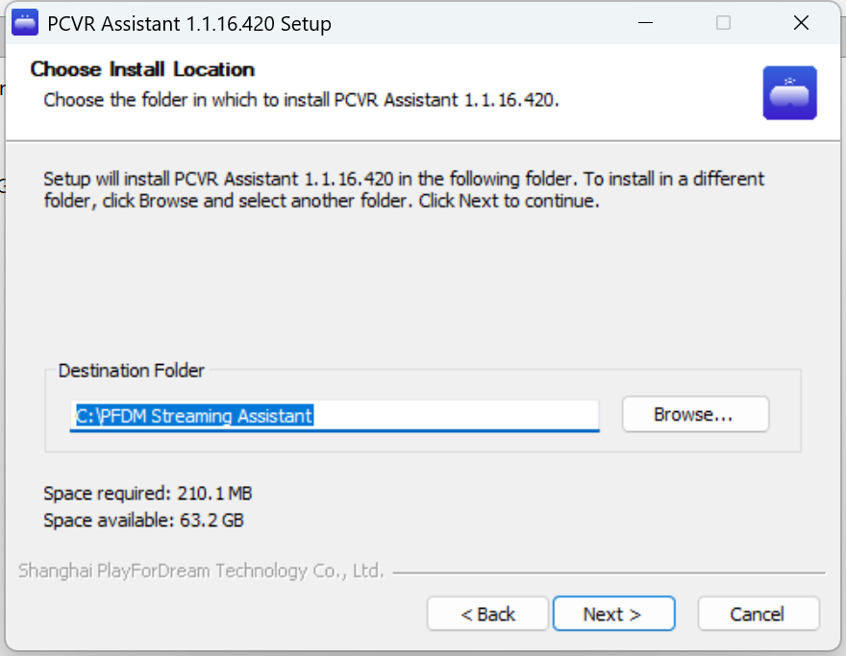
- Click Next to start installation
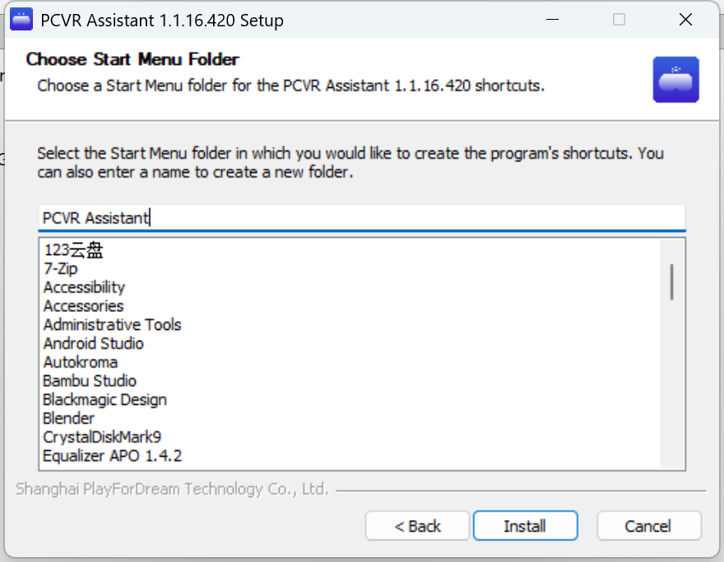
- Click the Close button to complete installation.
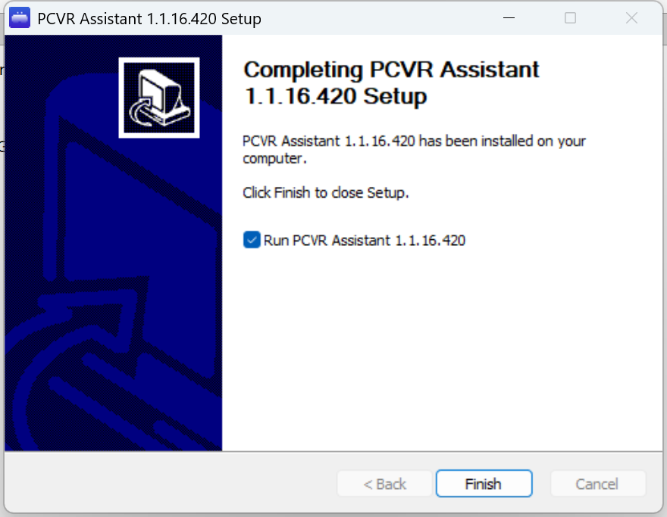
- On the desktop, find PFDM Streaming Assistant and double-click to open it
- Select Wireless Streaming on the left side (for wired streaming, we recommend using a USB 3.0 data cable with a recommended length of 5 meters or more)
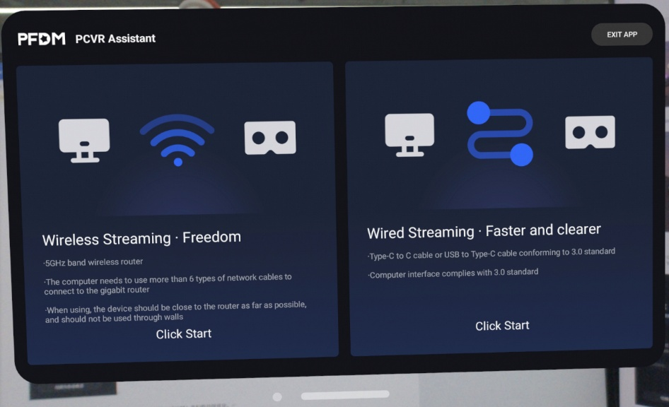

- After entering Wireless Streaming, the app will check your current environment. If the requirements are met, each module will show the corresponding status color.
PC Configuration Module: Test result in blue means the requirements are fully met; test result in yellow means the current streaming experience may not be very smooth; test result in red means the current configuration will greatly affect your streaming experience.
Steam Software: blue indicates that the required software is installed; red indicates that the required software is not installed.
Standalone Headset: blue indicates that the standalone headset has been found; red indicates that no standalone headset has been found.
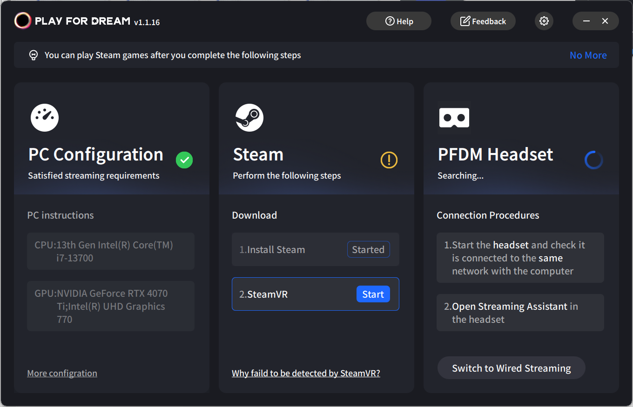

- After you launch PFDM Streaming Assistant, if Steam and SteamVR are already installed, SteamVR will start automatically. If you close SteamVR, you can also quickly launch it again through PFDM Streaming Assistant.
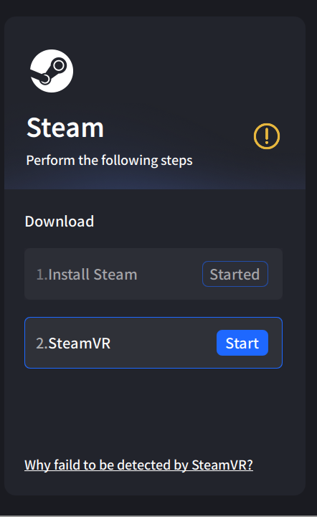
- PFDM Streaming Assistant is set to Standard mode by default. You can also manually adjust image quality and frame rate.
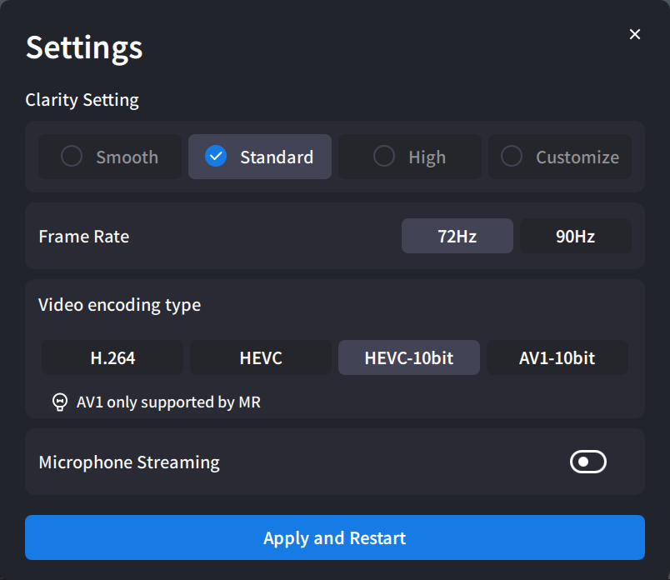
- At this point, please turn on and wear your PFDM headset, and make sure the PFDM headset and PC are connected to the same network (5 GHz Wi-Fi is recommended).
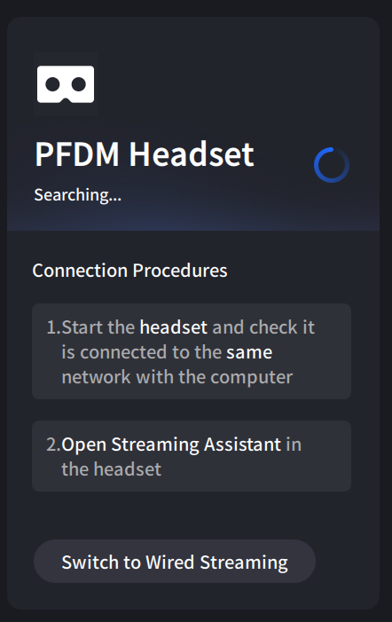
III. Open Streaming Assistant in the PFDM headset
1. Please turn on and wear your PFDM headset, and make sure the PFDM headset and PC are connected to the same network.
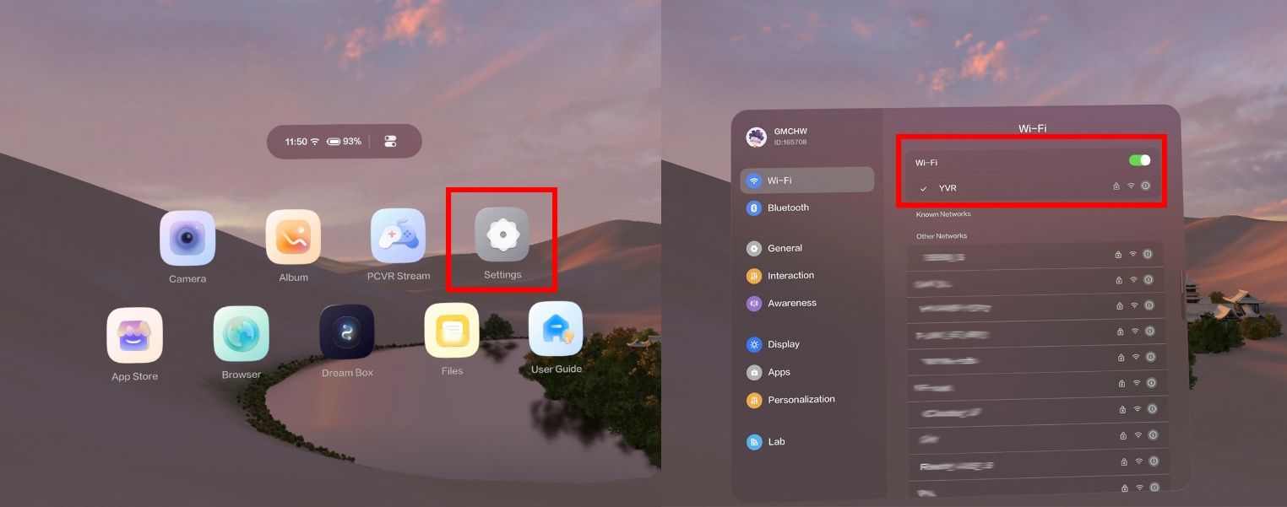

- Then press the right controller [Home button / ] to return to the home screen, then open PCVR Streaming
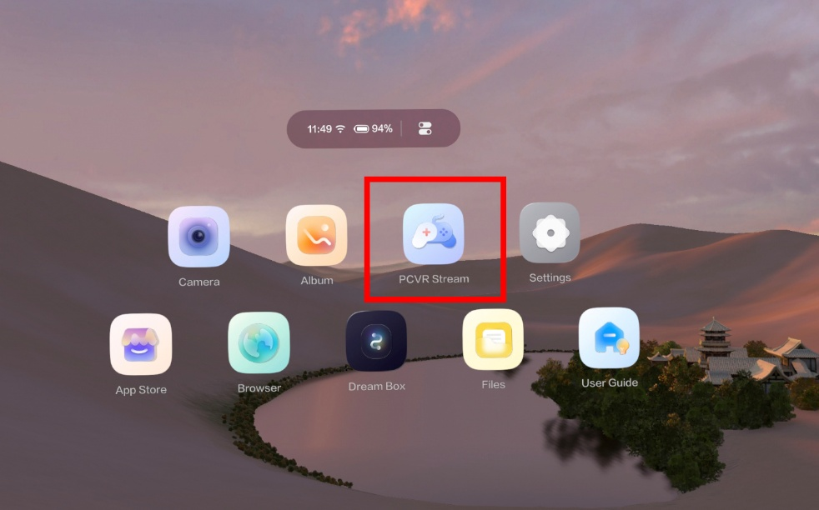

- After the connection succeeds, the status changes to [Connected]. Congratulations! You have successfully connected Streaming Assistant to the PFDM headset. You can now enjoy more content through wireless streaming.
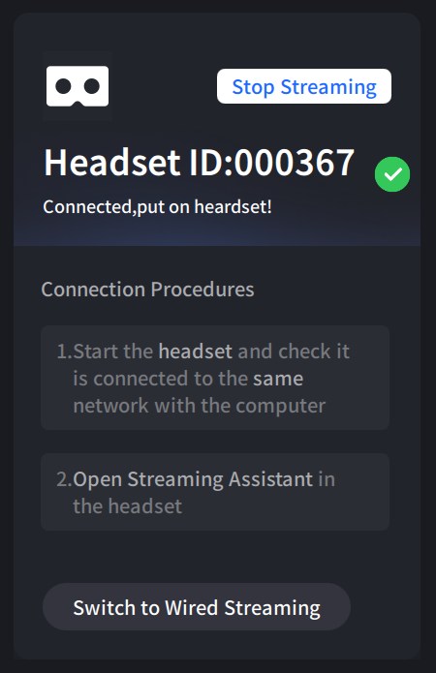

If there are any shortcomings in the steps above, please let us know. We apologize for any inconvenience caused and will continue to optimize the experience.

